# **Project Report: Supply Chain Analysis**

**Project Overview**

The Supply Chain Analysis project aims to provide actionable insights into the supply chain operations of a company. Using a detailed dataset, we analysed various aspects such as product sales, inventory management, supplier quality, shipping efficiency, and customer satisfaction. The results of these analyses help the company optimize its supply chain, reduce costs, and improve overall customer satisfaction.

**Data Description**

The dataset contained the following key features:

* **Product Information**: Product type, SKU, price, availability.
* **Sales Data**: Number of products sold; revenue generated.
* **Inventory Metrics**: Stock levels, order quantities, lead times.
* **Logistics Details**: Shipping times, shipping carriers, shipping costs, transportation modes, and routes.
* **Supplier Details**: Supplier names, defect rates, manufacturing costs.
* **Customer Information**: Demographics of customers making purchases.
* **Quality Control**: Inspection results and defect rates.

**Analysis Steps**

**1. Data Extraction and Cleaning:**

* Data was extracted from a database and cleaned to ensure consistency and accuracy. Irrelevant characters (e.g., commas, percentage signs) were removed to convert data into usable formats.

**2. Sales and Revenue Analysis:**

* We analysed the sales performance of various product types, identifying top-selling products and those contributing most to the revenue. This helped the company understand which products drive their business growth.

**3. Inventory Analysis:**

* Stock levels and lead times were assessed to determine optimal inventory levels. This analysis highlighted products that required restocking and helped in maintaining an efficient inventory system.

**4. Supplier and Location Analysis:**

* Analysed suppliers based on their defect rates to identify those consistently providing high-quality products. Additionally, shipping costs by location were assessed, revealing areas where shipping expenses were higher.

**5. Quality Control Analysis:**

* We classified complaints into different categories (e.g., product defects, late deliveries, damaged shipments) using logical conditions. This allowed us to pinpoint common issues and their root causes, improving customer satisfaction.

**6. Customer Demographics Analysis:**

* Analysed sales by customer demographics to understand the profile of key customers. This helped in tailoring marketing strategies to target high-value customer segments.

**7. Shipping Efficiency Analysis:**

* Evaluated shipping times and compared them with lead times to identify inefficiencies in the delivery process. This enabled the company to optimize logistics and improve delivery speeds.

**8. Cost Analysis:**

* Analysed manufacturing and shipping costs to understand the cost structure and identify opportunities for cost reduction. This included insights into high-cost locations and products with higher manufacturing expenses.

**9. Complaint Analysis:**

* Using calculated fields, we categorized complaints into "Product Defect," "Late Delivery," "Damaged Shipment," and "No Issues." The analysis revealed the most common complaint types and provided a basis for improving quality control and shipping processes.

**Data Visualization with Power BI**

The analysis results were visualized using Power BI, creating a user-friendly and interactive dashboard. Key insights were presented through various charts, such as bar charts, line charts, pie charts, and maps, making it easy for stakeholders to interpret the data.

Interactive elements like slicers allowed stakeholders to filter data by product type, location, and customer demographics, enhancing their ability to make informed decisions quickly.

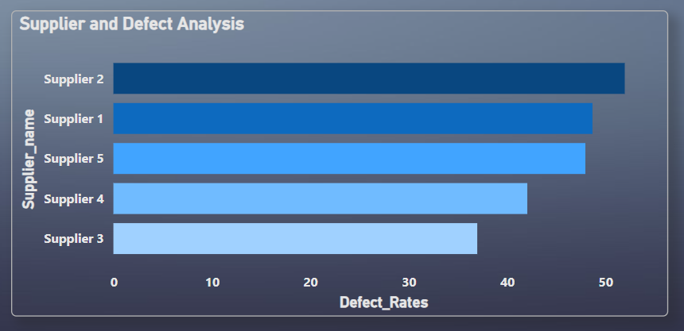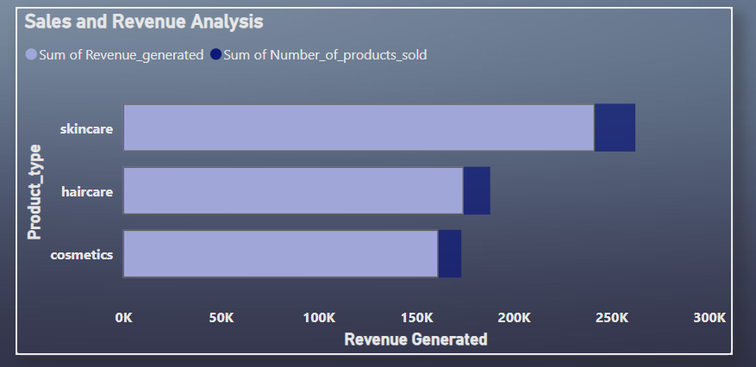

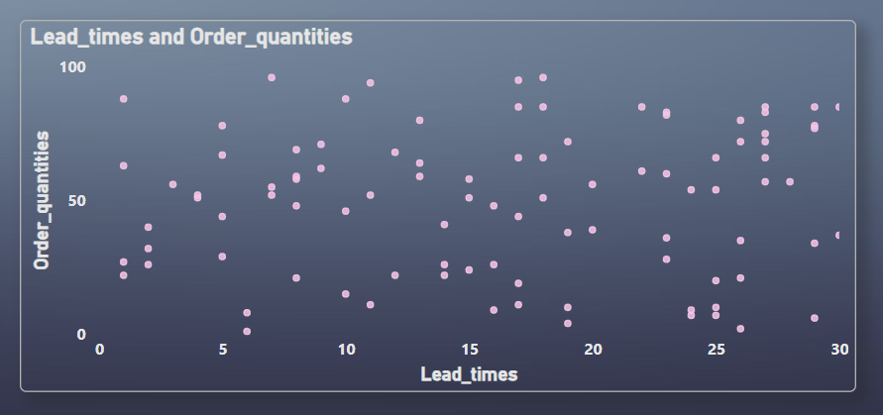

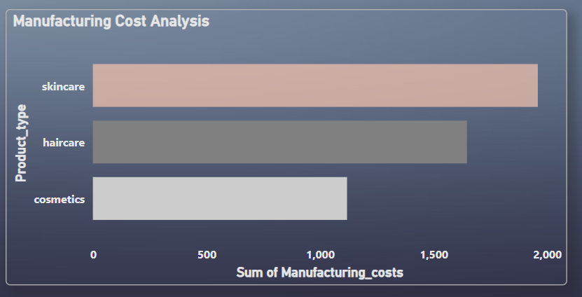

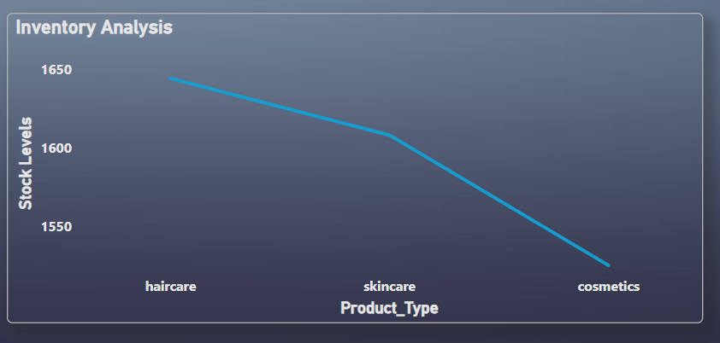

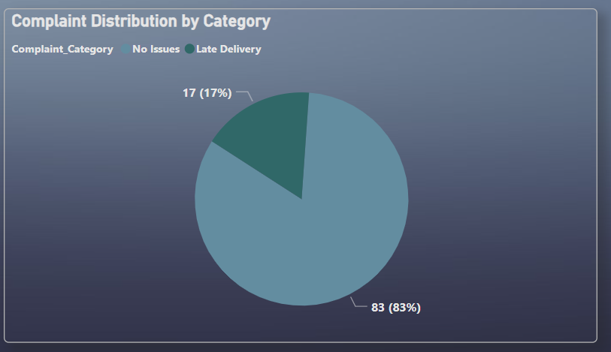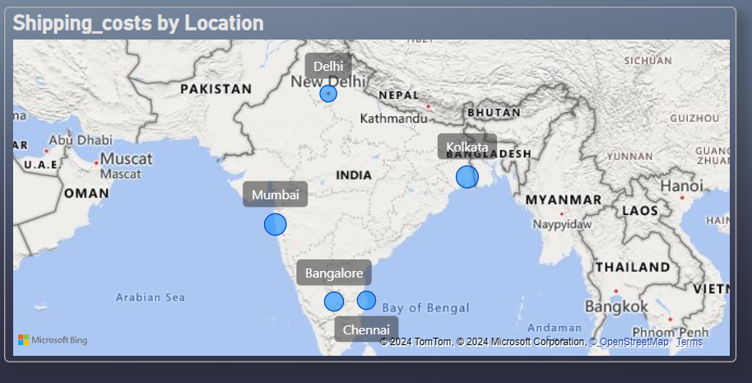

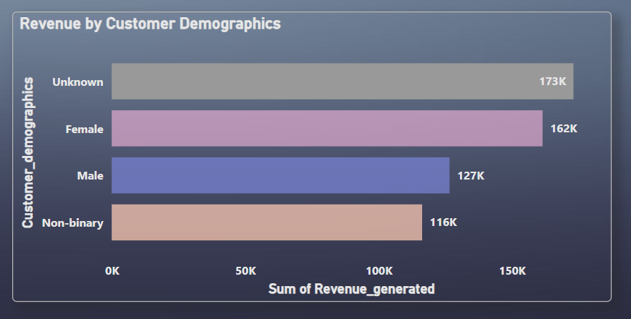

**Key Outcomes**

* **Improved Supplier Management**: Identification of suppliers with higher defect rates, allowing the company to negotiate better terms or seek alternative sources.
* **Optimized Inventory**: Insight into inventory levels and lead times, ensuring that stock is maintained at optimal levels and reducing stockouts or overstocking.
* **Enhanced Customer Satisfaction**: Understanding common complaint types led to targeted quality improvements, which enhanced customer satisfaction and reduced the rate of returns.
* **Cost Reduction**: Analysis of shipping and manufacturing costs helped to identify high-cost areas, offering opportunities for renegotiation with shipping carriers and suppliers.

## **Conclusion**

The Supply Chain Analysis project delivered a comprehensive view of the company's supply chain operations, uncovering valuable insights into sales trends, supplier quality, logistics efficiency, and customer behaviour. The findings and recommendations provided a roadmap for enhancing the company’s supply chain performance, leading to better decision-making, cost savings, and improved customer satisfaction. The interactive dashboard allows continuous monitoring of key metrics, ensuring that the company remains agile in a competitive market.